**Phuc Le**

**Student ID: 012360751**

**CS 151, Spring 2018**

**Professor: Dr. Kim**

**Programming Assignment 1**

1. **A set of use cases**

Use cases: Select ATM

|  |  |  |
| --- | --- | --- |
| Steps | User's action | System's Response |
| 1 |  | System print out the supported ATM and its correspond bank. |
| 2 | Enter the ATM name |  |
| 3 |  | System printout "[ATM's name] is selected". |

Use cases: Validate Creditcard

|  |  |  |
| --- | --- | --- |
| Steps | User's action | System's Response |
| 1 |  | The System printout "Please enter your card number" for user to enter card number |
| 2 | Enter the card number |  |
| 3 |  | System printout "This Card has expired and has been returned" when the card's expiration date has passed. |
| 4 |  | System printout "This card is not supported by this ATM and has been returned" when the credit card comes from different bank |
| 5 |  | System printout "Card Accepted" when the card is valid. |

Use cases: Validate password

|  |  |  |
| --- | --- | --- |
| Steps | User's action | System's Response |
| 1 |  | System printout "Please enter password". |
| 2 | Enter Password |  |
| 3 |  | System printout "Wrong password!" When the entered password is incorrect. |
| 4 |  | System printout "Authorization is accepted." When the password is matched. |

Use cases: Withdraw Money

|  |  |  |
| --- | --- | --- |
| Steps | User's action | System's Response |
| 1 |  | System printout "Start your transaction by entering the amount to withdraw.  ". |
| 2 | Enter the amount |  |
| 3 |  | System printout "This amount exceeds the maximum amount you can withdraw per transaction: [amount]" When the entered amount is over the limit of ATM. |
| 4 |  | System printout "[Withdrawal amount] is withdrawn from your account. The remaining balance of this account is [remain balance]. Enter quit to exit, no to continue" When the entered amount is valid. |
| 5 |  | System printout "The amount exceeds the current balance." When the requested amount is over the current balance. |
| 6 | Enter "no" | System printout "Start your transaction by entering the amount to withdraw.  ". Continue to step 1. |
| 7 | Enter "quit" | System printout "Exited" the program exited. |

1. **A set of CRC cards**

|  |  |
| --- | --- |
| Bank | |
| Create account  Handle validate Password  Handle withdraw request  Get balance from an Account | Account  Atm |

|  |  |
| --- | --- |
| Account | |
| Provide balance  Provide Creditcard | Bank  Creditcard |

|  |  |
| --- | --- |
| Atm | |
| Receive User’s Request, Input  Receive password request  Validate credit card  Receive withdraw request | ATMSystem  Bank  Creditcard  Bank |

|  |  |
| --- | --- |
| Creditcard | |
| Provide Bank information, password,  expiration date,  card number. | Account  Atm |

|  |  |
| --- | --- |
| ATMSystem | |
| Send validate password request  Send withdraw request  Send validate credit card requests. | Atm |

1. 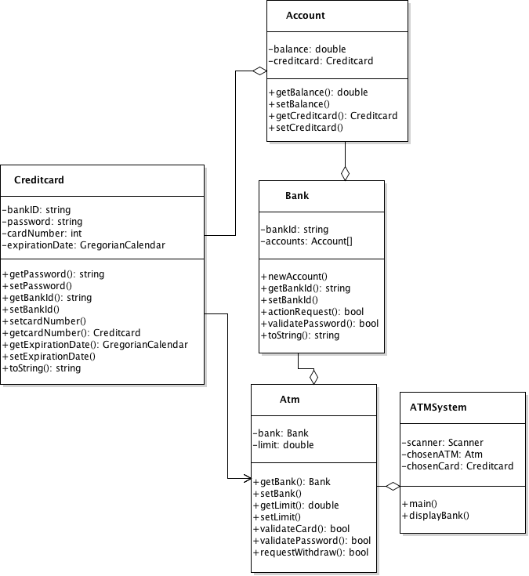**UML class diagram**